Task 2: Structural Simulation (FEA)
- Project Title: Structural Analysis of Connecting Rod
- Software Used: SolidWorks Simulation
- Material: Polished Aluminum

Objective
To perform a static structural analysis on a connecting rod and evaluate stress distribution, deformation, and factor of safety under an applied load

Boundary Conditions
- Fixed Geometry applied at the Big End Hole.
- Force of 1000 N applied at the Small End Hole.

Mesh
Standard SolidWorks mesh was used for the analysis.
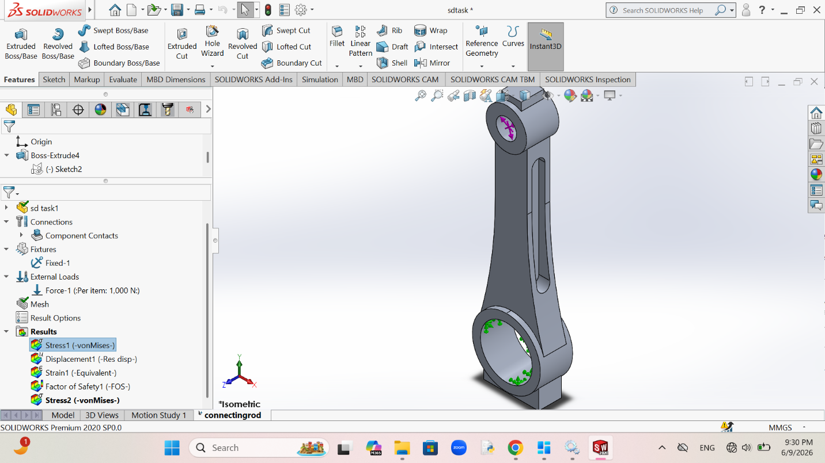
Figure 1

Stress Analysis
- Von Mises Stress Results

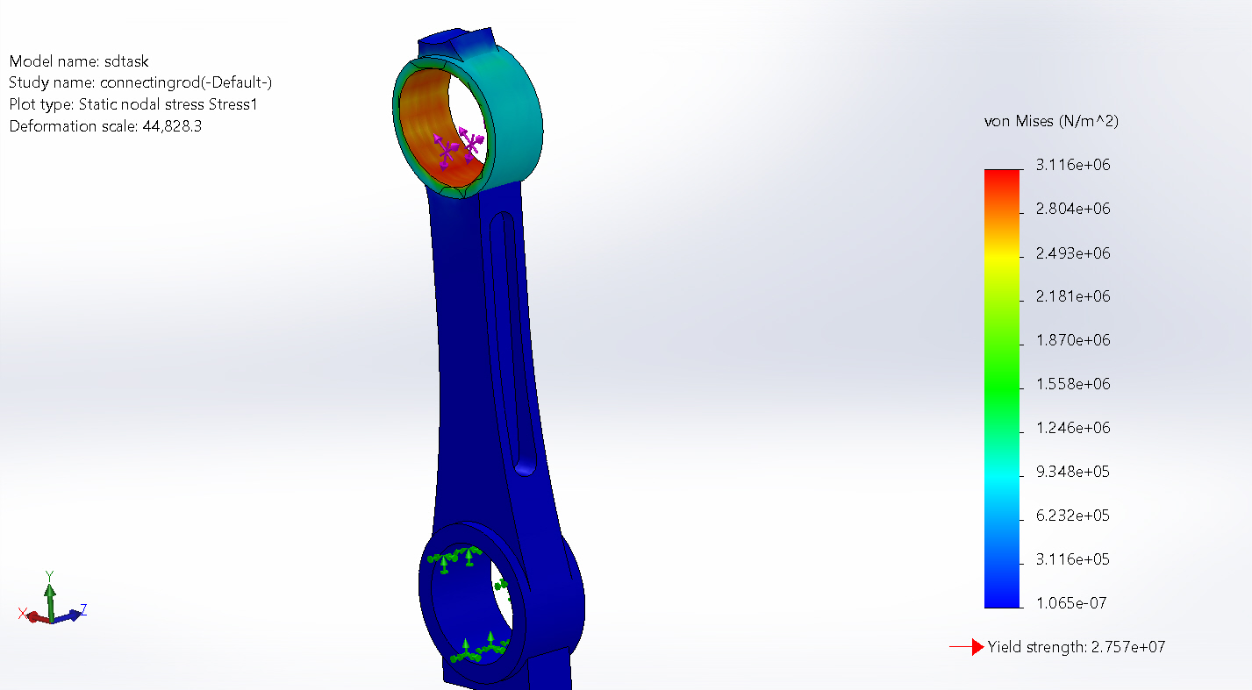
Figure 2
Maximum Stress:3.116e+06

Observation
The highest stress concentration appeared near the loaded region and geometric transitions.

Strain Analysis
- Strain Plot

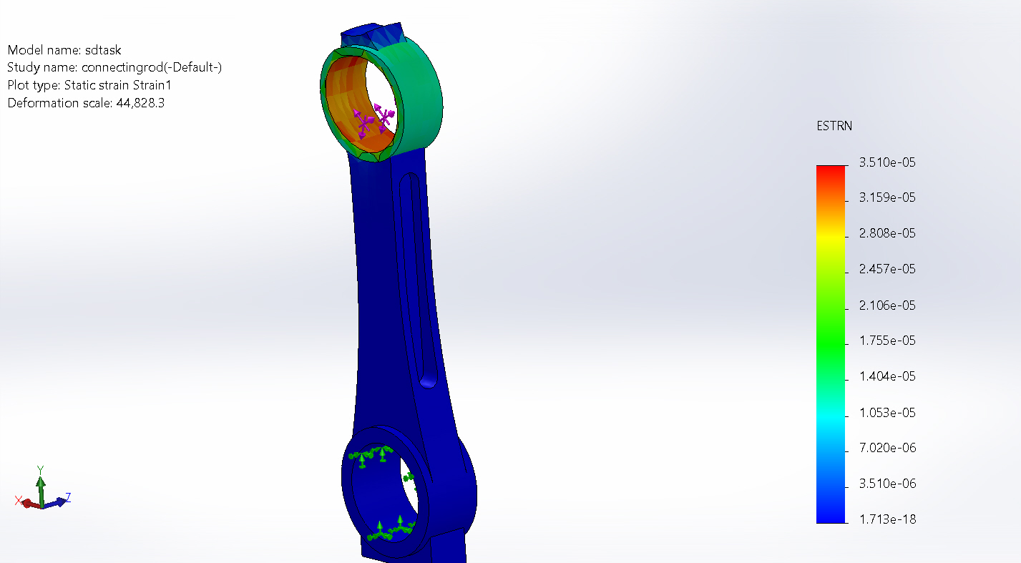
Figure 3
Maximum Strain:3.150e-05

Observation
The maximum stress was concentrated near the loaded region.

Displacement
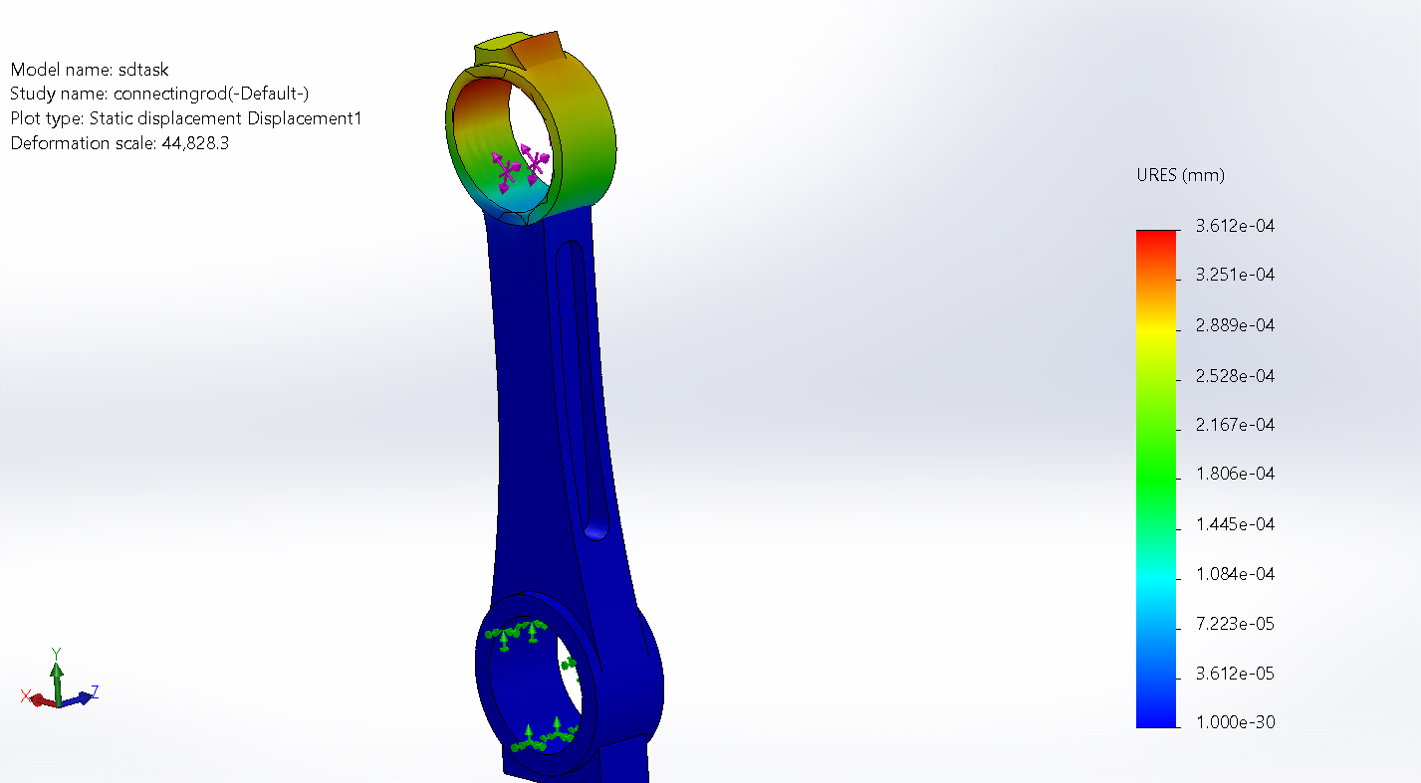
Figure 4

Maximum Displacement:3.612e-04

Factor Of Safety
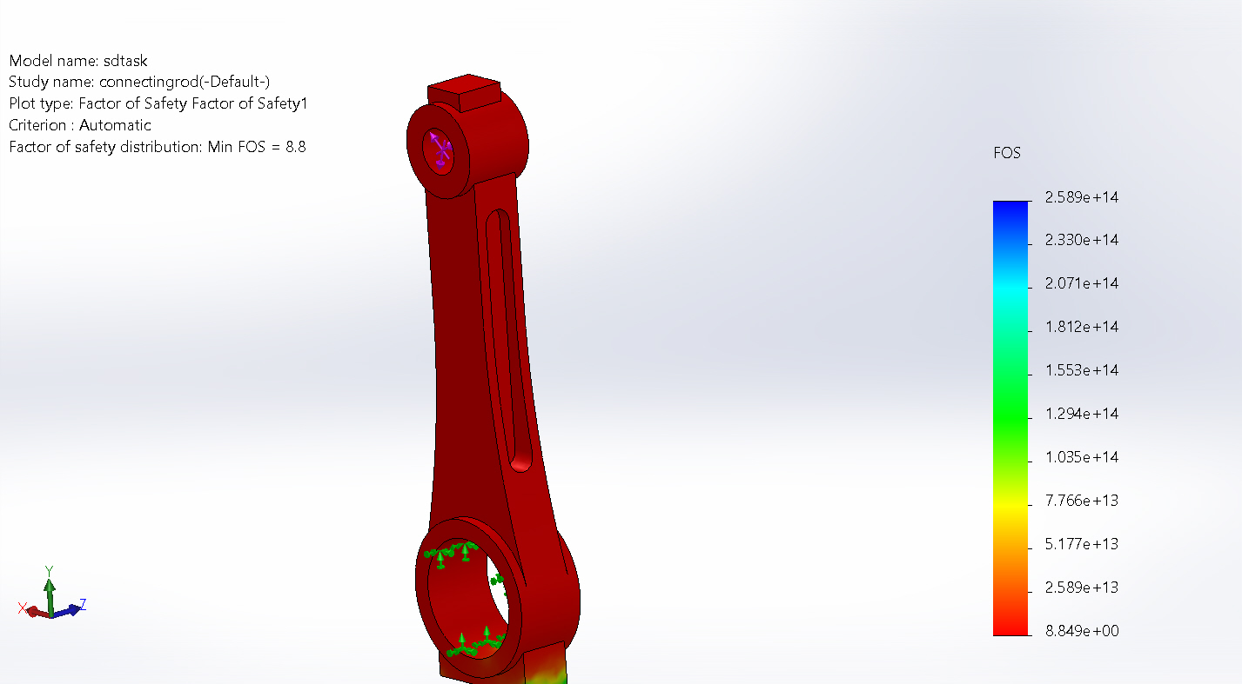
Figure 5
Minimum Factor Of Safety:2.589e+14

Conclusion
The connecting rod was successfully analyzed under static loading conditions. The obtained stress, strain, displacement, and factor of safety results provide an assessment of the structural behavior of the component.

